**Computer Networks Lab 7**

**Name: Vaibhav Chaudhari**

**ID: 2017B5A70834G**

**Write TCP client to download and locally save a file.  
  
1. The client, as a command-line argument, accepts the URL of the file. The URL can be HTTP or HTTPS-based. (2 marks)**



**Url of the file is:** [**http://www.vinayaknaik.info/index.html**](http://www.vinayaknaik.info/index.html) **which** **is taken** **as Command Line Argument.**

**2. If the URL does not exist or unreachable, the client prints an error and exits. (2 marks)**

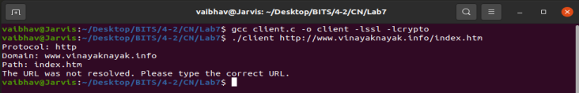

**The incorrect url given is :** [**http://www.vinayaknayak.info/index.html**](http://www.vinayaknayak.info/index.html) **which is the incorrect URL. The client code identifies it and gives the error message and exits.**

**3. After connecting to the server, the client sends a GET request to the server. (2 marks)**

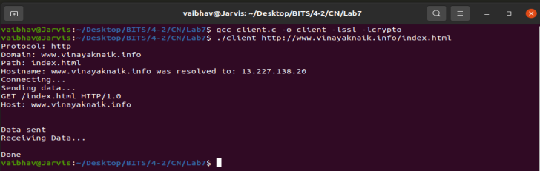

**Client sends a get request to the server.**

**4. The client downloads the whole file and saves it to the local folder with the same file name as mentioned in the URL. (8 marks)**

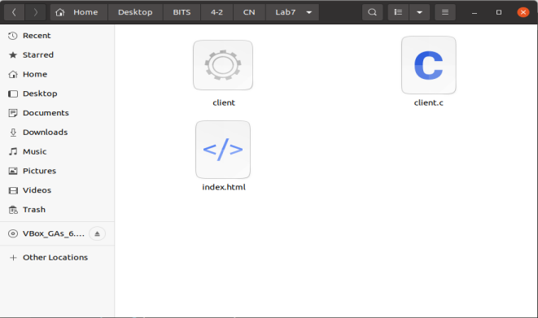

**The file is downloaded in the same folder with the same name which is mentioned in the URL.**

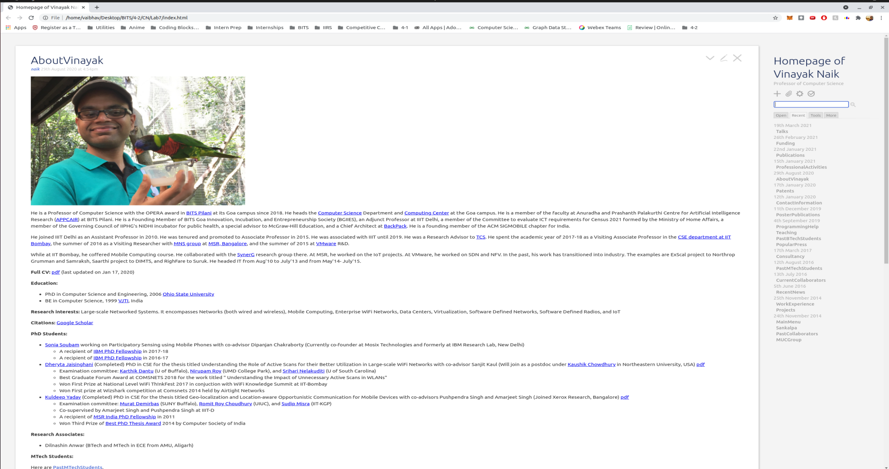

**The file is opening as seen in the above picture.**

**5. If a file with the same name exists, the old file is overwritten. (1 mark)**

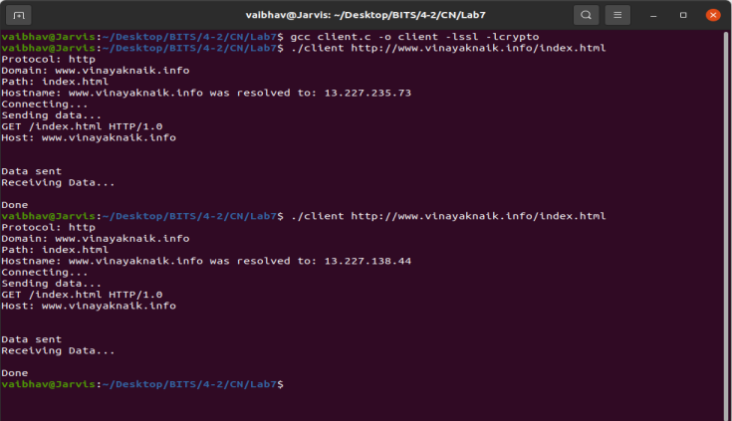

**When the same file is again downloaded, the old file is overwritten in the same folder.**

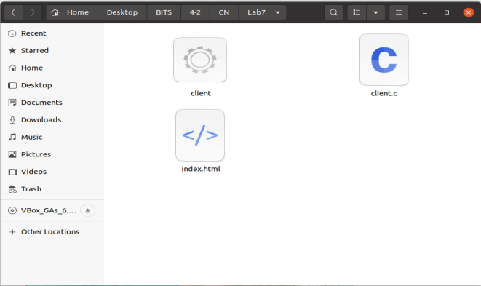

**The overwritten file can be seen in the folder.**

**6. The client exits after downloading the file. (1 mark)**

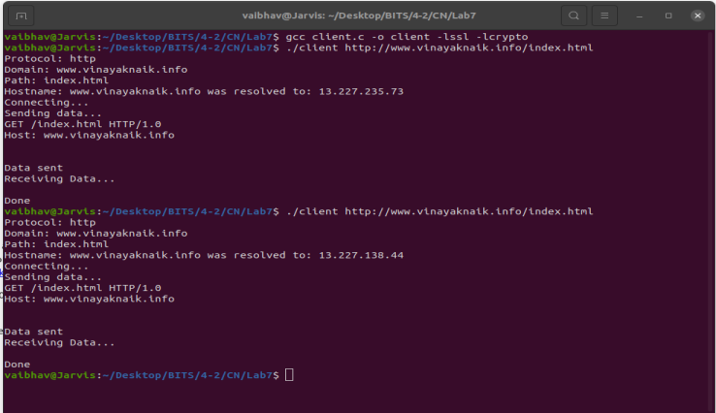

**The client exits after downloading the file everytime.**

**We can even download pdf from the net using this. Below screenshot shows this**

**URL :** [**http://www.axmag.com/download/pdfurl-guide.pdf**](http://www.axmag.com/download/pdfurl-guide.pdf)

